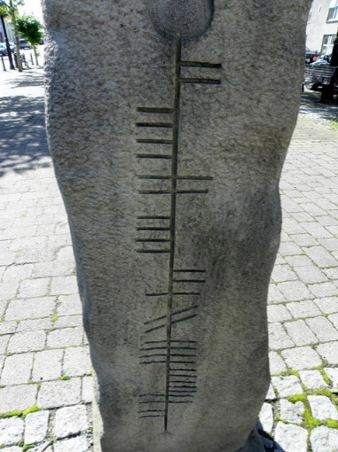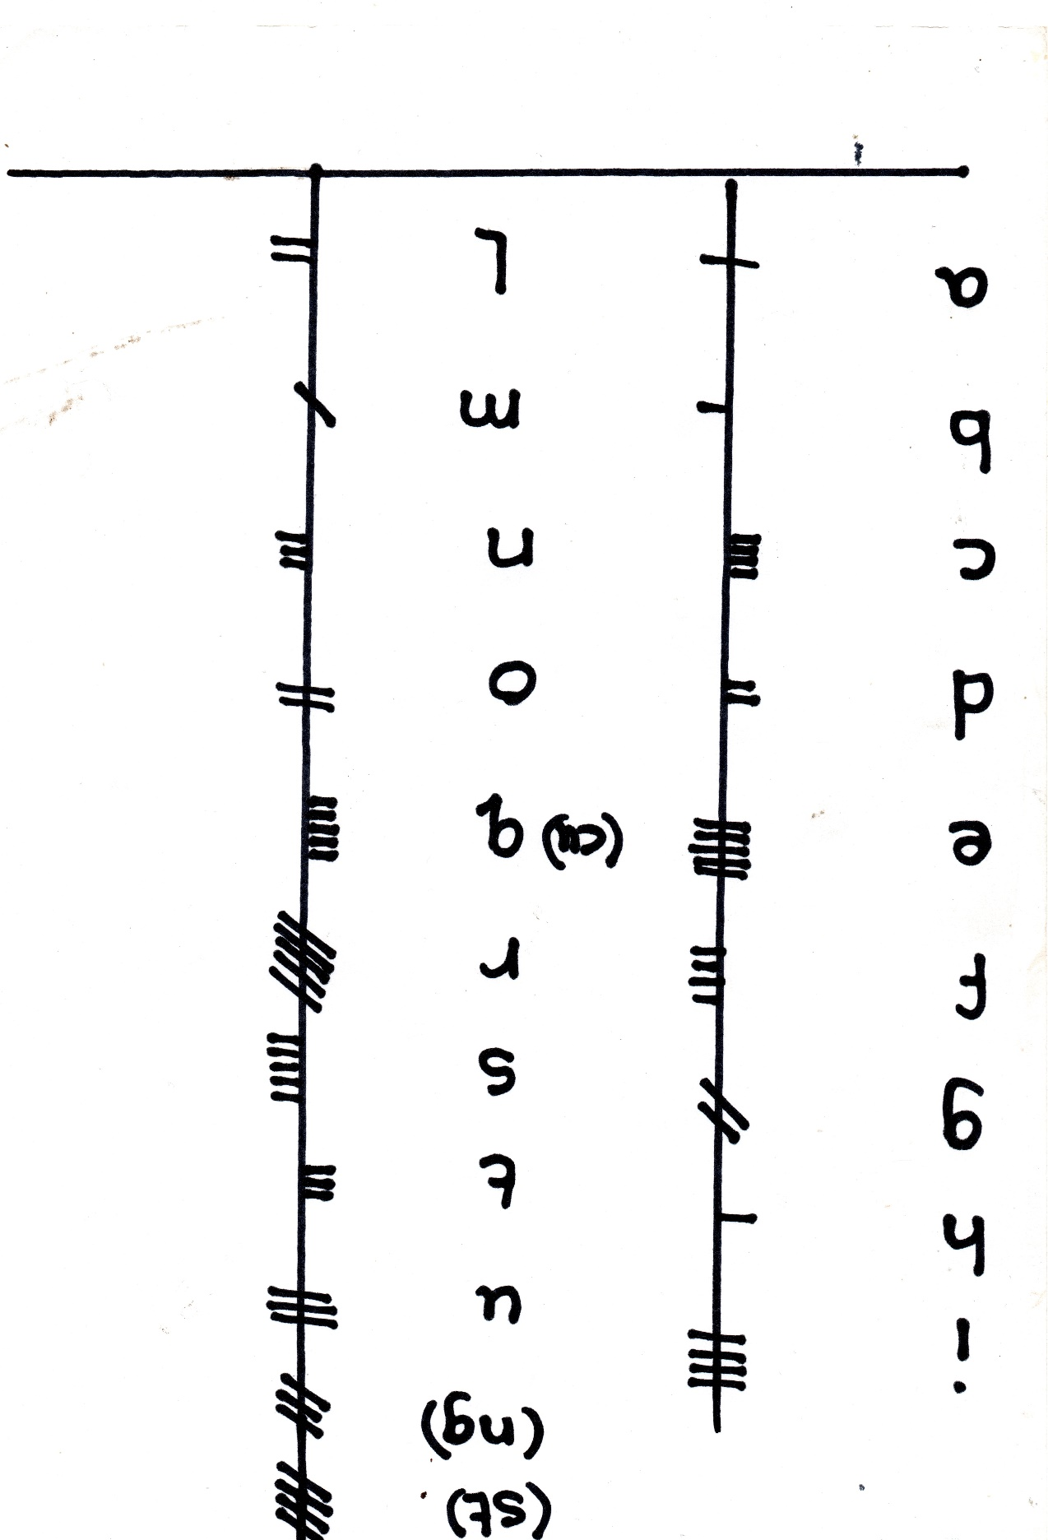

Ogham was a method of keeping records. Originally each sign contained ‘information that may have helped poets to remember ideas and stories. No-one, today, knows for sure.

Later the signs were used as an alphabet to carve the names of important people and places on marker stones.