|  |
| --- |
| Describe your best jewellery. |
|  |
|  |
|  |
|  |

|  |
| --- |
| What are your special skills? |
|  |
|  |
|  |
|  |
| Have you any magic stuff? |
|  |
|  |
|  |
|  |

**[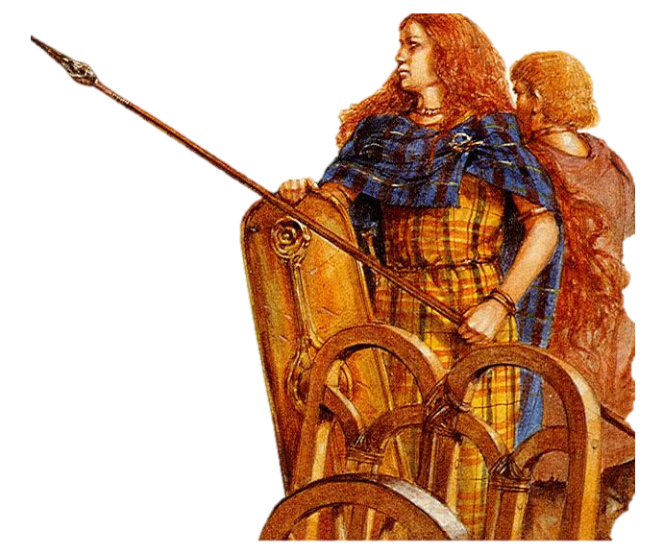](https://www.pinterest.ie/pin/301952349990865308/)**

Can you drive a chariot?

Name ______________________________________ *Chris Thomson 18*

Draw yourself in your best clothes.

If you wanted to be chosen as a queen in one of the old Irish stories. You would have to :

* dress up in lots of jewellery and bright coloured clothes
* Be rich (have lots of cows)
* tell everyone how clever you are. (or get a poet to do it for you)
* have some special (show-off) skills
* maybe own some magical weapons or other items.

**2. If you were Queen … ………**