|  |
| --- |
|  |
|  |
|  |
|  |
|  |
|  |

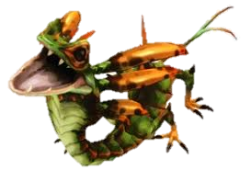

Name ______________________________________ *Chris Thomson 18*

How would you defeat your Péiste? Will you trick it or will you discover a magic weapon?

Draw a really *horrible* Péiste? What colours will you use?

1. **The Mysterious Péiste**