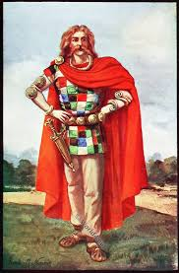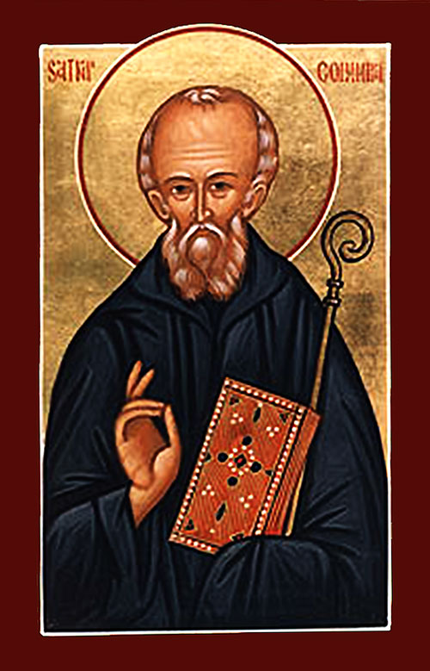 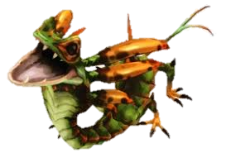

1. **The Mysterious Péiste**

Saint Columbkille met a Péiste when he went to Scotland. It was a huge and dangerous creature that wanted to eat him. He persuaded it to go away and leave him alone. He told it never to return to Loch Ness.

Columbkille had a very loud voice and he was very clever with words. Perhaps that helped him to get away. He may have escaped, the beast but some people believe there is still a monster in Loch Ness. What do you think?

King Fergus managed to bring back his good looks by defeating the water monster.

He had his magic ear-herbs that allowed him to walk and breathe under the water. They helped him.

He also had a sharp sword. Perhaps it was a magic one that he found in ‘Land Under Wave’.

.

A Péiste was a kind of water monster that lived in a loch.

They might look like worms or crawling serpents. They could be very scary. They could get bigger and bigger becoming hideous and horrible as they inflated.

A glimpse of one was supposed to turn you mad with fear or make your face ugly with terror.

Once, stories tell, there was a Péiste in every lake in Ireland but they are all gone now … or are they?